Name :SK.Kashifa

Registration no :192121135

Land registration system

Class diagram :

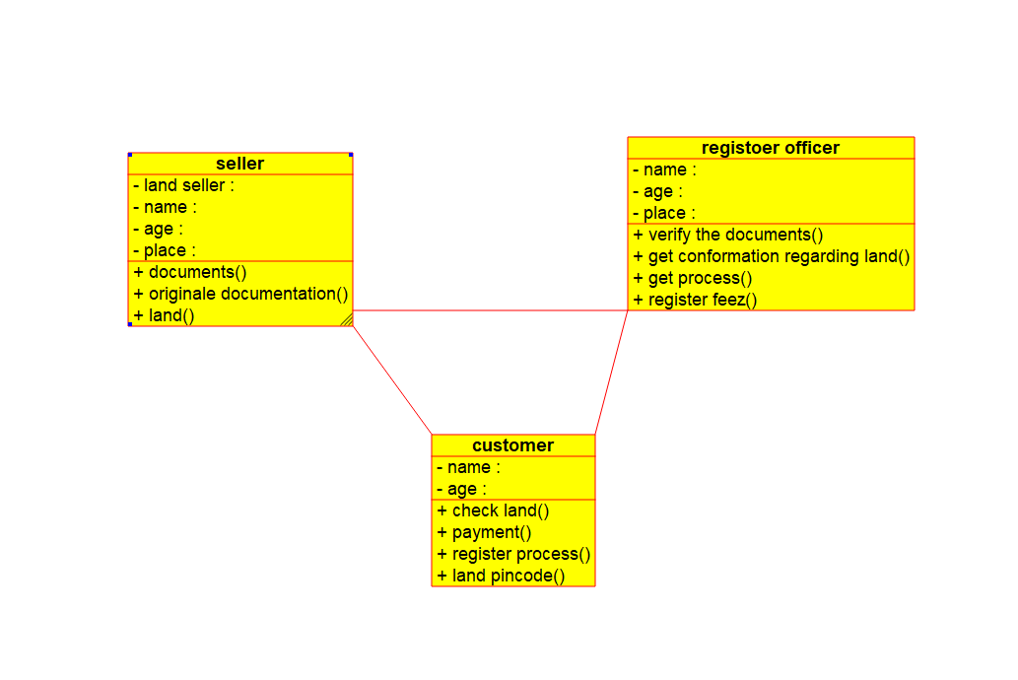

Usecase diagram :

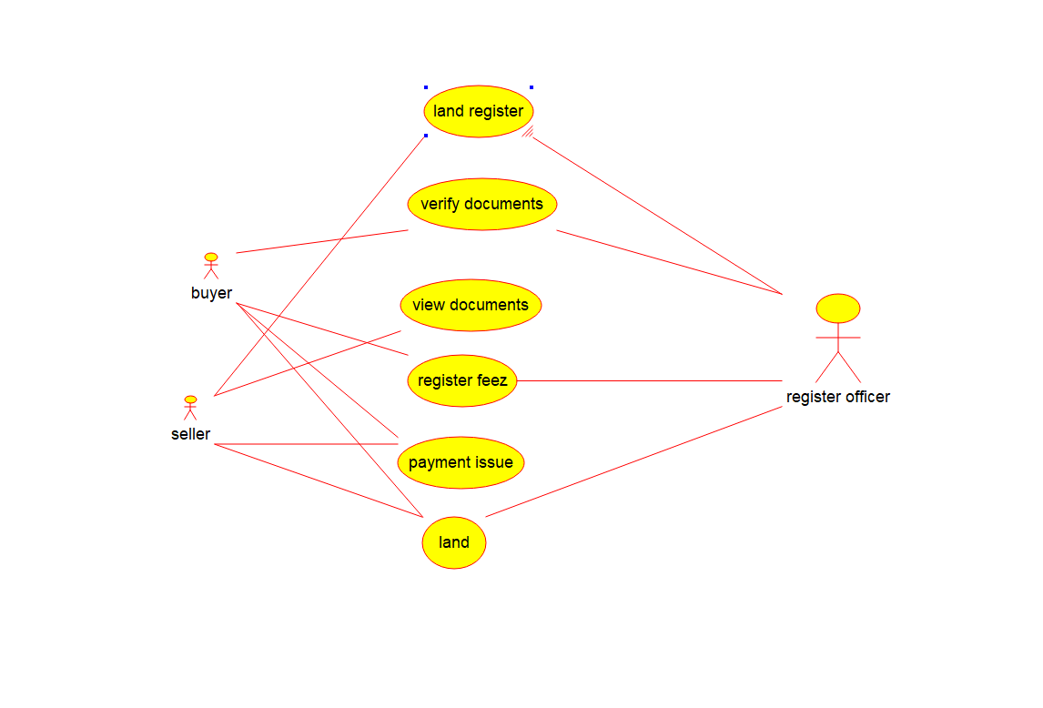

Sequence diagram :

